OOP lab 11
Q1
Source code
class lab11:
def divide(self):
try:
a = int(input("Enter a: "))
b = int(input("Enter b: "))
c = a/b
print("a/b = %d"%c)
except Exception:
print("Can't divide by zero")
else:
print("Hi, i am else block")

nabeel = lab11()
nabeel.divide()

Output
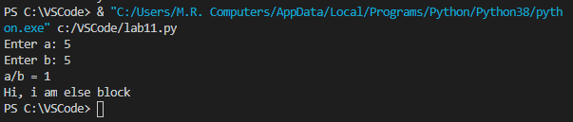

Q2
Source code
class lab11:
def fil(self):
try:
fileptr = open("file.txt","r")
except IOError:
print("File not found")
else:
print("The file opened successfully")
filepptr.close()

nabeel = lab11()
nabeel.fil()

Output
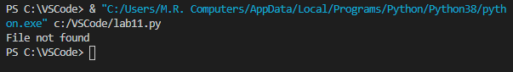

Q3
Source code
class lab11:
def fil(self):
try:
fileptr = open("file.txt","r")
try:
filetr.write("Hi i am good")
finally:
fileptr.close()
print("file closed")
except:
print("Error")

nabeel = lab11()
nabeel.fil()

Output
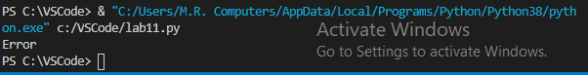

Q4
Source code
class lab11:
def fil(self):
try:
age = int(input("Enter the age: "))
if age<19:
raise ValueError
else:
print("Age is valid")
except ValueError:
print("The age is not valid")

nabeel = lab11()
nabeel.fil()

Output
